

**SECP 1513  
TECHNOLOGY AND INFORMATION SYSTEMS**

**Project: Design Thinking  
Theme: Future Digital Campus**

**Section: 04 - Group: 09**Dr. Shafaatunnur Binti Hasan

Modern UTM Bus Navigation System

|  |  |  |  |  |
| --- | --- | --- | --- | --- |
|  |  |  |  |  |
| Mohammed Rahbab Chowdhury  **A25CS0013** | Abdulrahman Mohammed **A25CS0003** | Khalid **A23CS4042** | Nasma Mutasim **A25CS5054** | Basma Mutasim **A25CS5053** |

**Table of Contents**

1. **Introduction** ...................................................................................................................... **3**
2. **Detail Steps and Descriptions in Design Thinking** ........................................................ **4**  
   2.1 Empathy Phase   
   2.2 Define Phase   
   2.3 Ideate Phase   
   2.4 Prototype Phase  
   2.5 Test Phase
3. **Detailed Descriptions: Problem, Solution, and Team Working** ................................... **5**  
   3.1 Problem Identified,  
   3.2 Proposed Solution   
   3.3 Team Working
4. **Design Thinking Assessment Points** ................................................................................ **6**
5. **Design Thinking Evidence** ............................................................................................... **7**  
   5.1 Empathy Phase   
   5.2 Define Phase   
   5.3 Ideate Phase   
   5.4 Prototype Phase  
   5.5 Test Phase
6. **Reflections (Individual)** ..................................................   
   6.1 Member 1: Khalid  
   6.2 Member 2: Abdulrahman Mohammed  
   6.3 Member 3: Mohammed Rahbab Chowdhury  
   6.4 Member 4: Nasma Mutasim  
   6.5 Member 5: Basma Mutasim
7. **Task for Each Member** .........................................................
8. **References** .................................................................................

**1. Introduction**

This report highlights the use of Design Thinking as a systematic methodology to develop and test a Modern UTM Bus Navigation System following the “Future Digital Campus” theme. It aims to address some of the most significant inefficiencies in campus transportation logistics and uses a user-centered design method that does not require any back-end development.

This system is designed to improve campus mobility, provide greater transparency of operations, and improve users' experiences with mobile applications. The system will include several integrated components: real-time bus tracking, predictive arrival analytics, crowd density indicators, and personalized notifications. The target audience is made up of students, academic and administrative employees, and visitors to the campus.

The project will follow a Design Thinking five-phase model that consists of Empathy, Define, Ideate, Prototype, and Test. The development will incorporate qualitative user research, iterative design prototyping in Figma, and usability testing to ensure design decisions were made for a high-fidelity non-functional prototype, which will display the flow of interfaces, pathways for user interaction, integrated features, and pain points of UTM's current transportation ecosystem.

This report provides a comprehensive breakdown of each design phase, supported by empirical evidence, user feedback, and reflective analysis, aligning with the broader objective of leveraging technology to optimize campus infrastructure and support institutional digital transformation.

**2. Detail Steps and Descriptions in Design Thinking**

**2.1 Empathy Phase**

We tried to understand the user experience on UTM buses. Our interviews and surveys ranged across multiple user groups (i.e. students, staff, parents), to get a comprehensive idea of how the current bus system is perceived across the board. The interviews were conducted at bus stops during peak hours. Additionally, we also decided to use the bus routes unfamiliar to us to put us in the shoes of the user and experience it ourselves.

**2.2 Define Phase**

After gathering interviews and survey data, we used affinity mapping to identify patterns. Five core problems emerged: lack of real-time information, unreliable schedules causing anxiety, language barriers for certain users, crowding issues at peak times, and visitor confusion with routes. This analysis led us to focus on creating a solution that would provide real-time bus tracking and reduce the anxiety of waiting without information.

**2.3 Ideate Phase**

The team conducted two brainstorming sessions to generate solutions. The first session produced initial ideas, while the second helped us expand and refine them. In total, we came up with around 15-20 potential solutions.

We evaluated each idea based on feasibility and user impact. After thorough discussion, the GPS tracked bus emerged as the strongest solution because it directly addresses the "where is the bus?" problem and aligns with how users already interact with ride-hailing apps like Grab.

**2.4 Prototype Phase**

For this phase, we started by sketching and later developed the prototype using Figma. As we worked through the design, we added more features based on the Ideate phase. The goal was to create something functional enough to test the main concept without overcomplicating it. We focused on whether users could understand where their bus was and when it would arrive.

**2.5 Test Phase**

We showed it to students at CP Bus stop and shared it on Telegram groups as well, along with a feedback link. They tried locating their bus and checking when it would arrive at their stop and liked the fact they could locate buses in real time. The main takeaway was that the tracking feature solved the core problem, but additional features such as a bus arrival notification were requested.

**3. Detailed Descriptions: Problem, Solution, and Team Working**

**3.1 Problem Identified**

The existing UTM bus system suffers from an information gap, mainly the lack of real-time data availability. Lack of live GPS data makes for an unintuitive UX and commuters as a result suffer unpredictable waiting times. The result of this is seen in the inefficient route planning users complain about, and the overcrowding at most bus stops.

Unfortunately, the current system defies the usability features of good systems by making commuting mentally exhausting. Instead of having clear data to rely on, students and other commuters must guess when the next bus will be coming and whether they have missed their bus already. This results in a loss of productivity for all

**3.2 Proposed Solution**

To deal with the above issues, we propose a Modern UTM Bus Navigation System that is all about transparency and user support. This system is loaded with features that will make transportation inside campus a pleasant and inviting experience.

The system leverages real, time GPS tracking and automated notifications to give users accurate bus location information, arrival time estimates, and instant service updates. Instead of guessing, students now have real, time data and estimated crowd levels at their disposal, which allows them to better schedule their activities and pick less crowded times for their travels.

Moreover, an exclusive "Accessibility Mode" not only shows the buses equipped with wheelchair-ramps and suitable for special-need users but also guarantees the journey is made accessible to all users. Apart from facilitating current navigation, the system also collects anonymous accessibility data which serves as a research tool and a continuous reminder of the university's commitment to a campus that is fully accessible to all categories.

**3.3 Team Working**

We communicated primarily through WhatsApp for daily updates and quick coordination. Formal team meetings were held twice weekly on weekends via Zoom and in-person when possible. Google Drive was used for file sharing, storing interview transcripts, research photos, and design files. Microsoft Office SharePoint was used for collaborative notetaking during discussions. We also used Canva and Figma to make diagrams and store our ideas.

One of the team’s challenges was to schedule testing sessions since we needed to be at bus stops during peak hours. We worked around individual class schedules to ensure at least two of our team members could attend each session - one to demonstrate the prototype and another to observe and document feedback.

**4. Design Thinking Assessment Points**

We made sure to integrate assessment across all five design thinking phases throughout the Design Thinking process to ensure the system remained feasible and aligned with the “Future Digital Campus” theme.

Assessment was conducted at four key stages.

**Phase Transition Gates**  
- After the Empathy Phase, user interviews, surveys, and observations were reviewed to ensure key pain points were clearly identified.   
- Following the Define Phase, the problem statement was evaluated for clarity, relevance, and scope.   
- Prior to prototyping, ideated solutions were assessed based on feasibility, impact, and alignment with user needs. These checkpoints prevented premature design decisions and kept the project focused.

**Weekly Progress Reviews**  
Meetings were held to monitor progress and task completion. These reviews helped identify challenges early, improve team coordination, and ensure consistency between research findings, prototype development, and report documentation.

**User Testing Milestones**  
User testing served as a major assessment component and was conducted after each prototype iteration. Users were asked to locate buses, interpret arrival times, and navigate routes using the prototype. Feedback was collected through direct observation and short surveys. The results informed design improvements, such as clearer route direction indicators and enhanced arrival time visibility, ensuring the system effectively reduced uncertainty and waiting anxiety.

**Final Integration Check**  
A final review was conducted before submission to assess the system as a complete solution. This included evaluating interface flow, feature consistency, usability, accessibility considerations, and alignment with initial user research. Remaining usability issues were resolved to ensure a coherent and intuitive high-fidelity prototype.

This continuous assessment approach strengthened the overall design outcome and demonstrated the practical application of Design Thinking in addressing real campus transportation challenges.

**5. Design Thinking Evidence**

**5.1 Empathy Phase**

We began by understanding user pain points through:

* **Interviews:** Conducted with 10 students, 2 academic staff, and 1 visitor.
* **Surveys:** Shared across student Telegram groups
* **Observations:** Spent time at UTM bus stops during peak hours.
* **Persona Creation:** Developed two composite user personas:
  + **Student Persona:** Ali, 20, Engineering student, relies on buses to reach classes on time.
  + **Visitor Persona:** Mr. Lee, 45, parents visiting campus for the first time.

|  |  |
| --- | --- |
| Ali, 20, Engineering student | Mr. Lee, 45, parent |

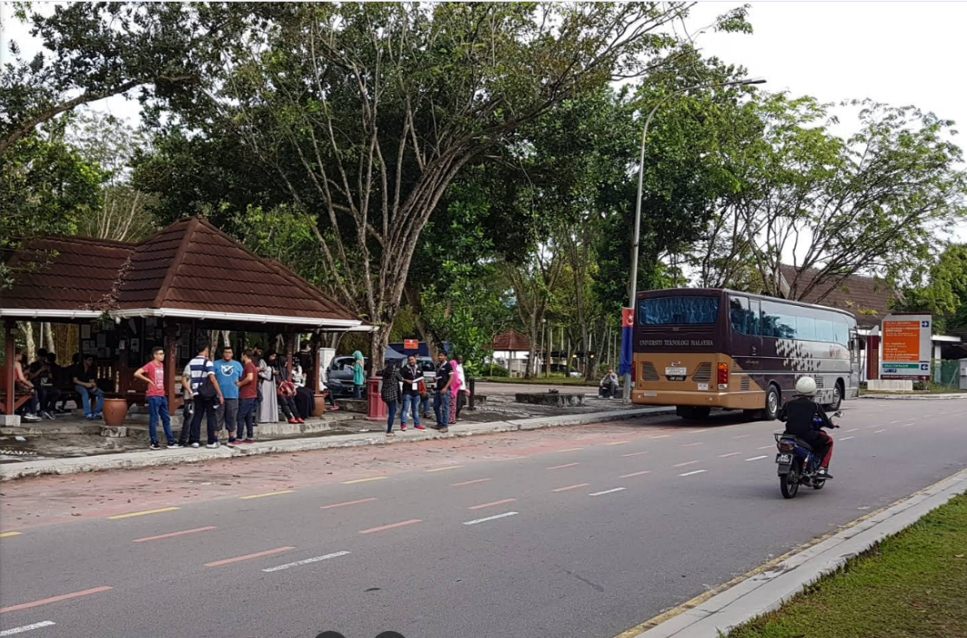

|  |
| --- |
| **Interview Transcripts** - Ali, 20, Engineering Student  **Date**: 10 Jan 2026  **Location:** Faculty of Electrical Engineering-FKE-P19 (Bus Stop)- UTM  **Interviewer:** Khalid  **Interviewee Code:** S01 (Student, Year 2, Mechanical Engineering)  **Q1: How often do you use UTM buses?**  A: *Almost every day. I have classes in FKAB and stay at KK2. So, morning, after class,*  *sometimes evening if I stay late at library.*  **Q2: What is the biggest problem you face with the buses?**  A: *The timing.....it's so unpredictable. Sometimes bus comes early, sometimes 10-15*  *minutes late. I missed my 8 AM class twice this month because of that.*  **Q3: Do you use any app or system to check bus timing now?**  A: *No, there's no real app. Sometimes I check the schedule poster at the bus stop, but it's*  *not updated. Mostly I just wait and hope. It'd be really helpful if there was something*  **Q4: How do you feel while waiting?**  A: *Stressed. Especially when it's hot or raining. And if I'm alone, I keep checking my*  *phone, thinking maybe I missed it.*  **Q5: What feature would help you the most?**  A: *Live tracking. Like Grab but for buses. If I can see the bus on map, I can plan when to*  *leave my room. The public bus P211 to Taman U has that feature on the Lugo app.* |
| **-----------------------------** |
| **Interview Transcripts -** Mr. Lee, 45, parent  **Date:** 10 Jan 2026  **Location:** Near to CenterPoint Bus Stop (CP)-UTM  **Interviewer:** Khalid  **Interviewee Code:** V01 (Visitor, Parent of a student)  **Q1: Is this your first time visiting UTM?**  **A:** *Yes, came to see my daughter. Campus is big, I'm not sure where to go. I was very*  *confused. *laughs\**  **Q2: Did you use the bus today?**  **A:** *I tried, but I don't know where it goes. No clear information for visitors. Had to keep asking students for help*  **Q3: What kind of information would help visitors?**  **A***: A simple map with bus stops and maybe a "Where am I?" feature. And maybe voice*  announcement of the bus stop name. |

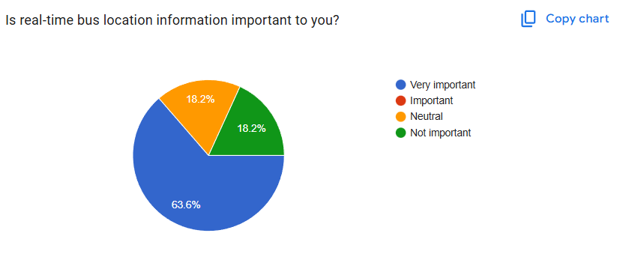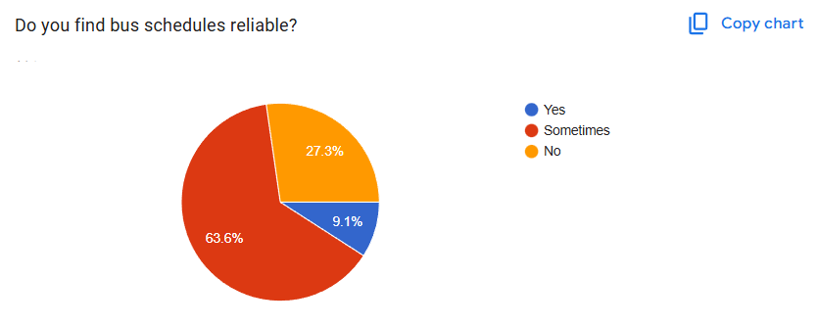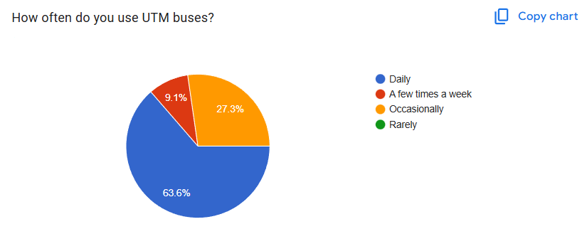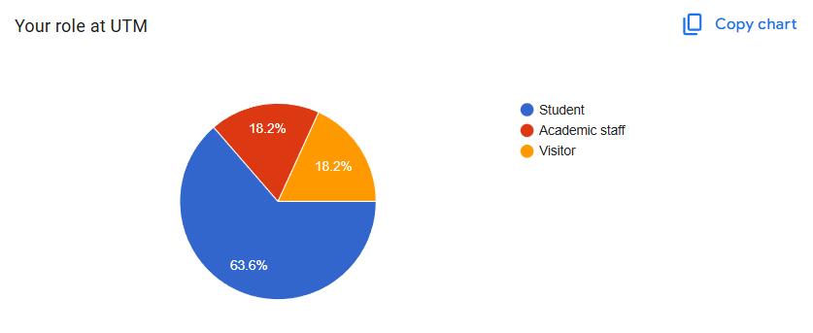**Google Forms Survey Responses:**

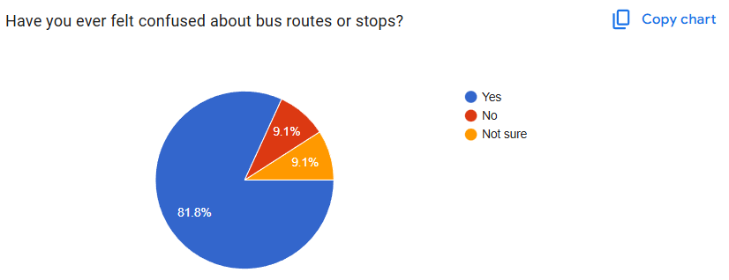

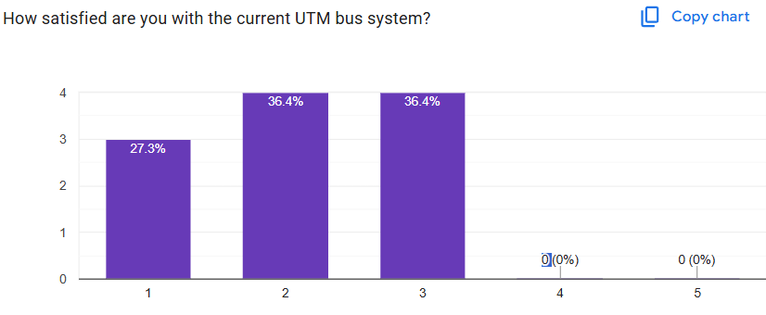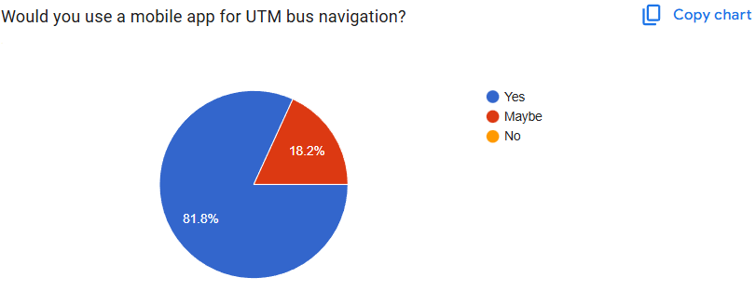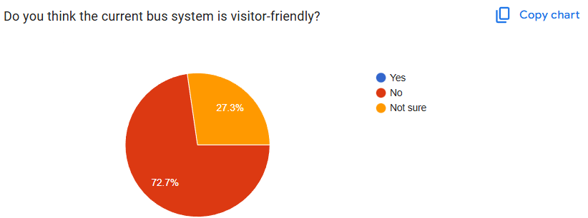

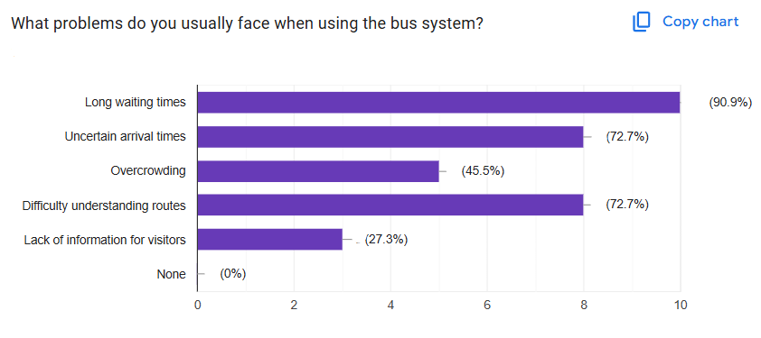

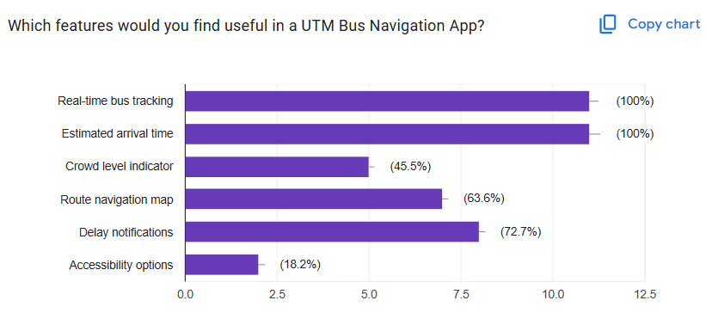

**5.2 Define Phase**

Synthesizing our research data, we identified five core problems through affinity mapping and problem statement workshops:

1. **Information Asymmetry:** Users lack access to real-time bus locations and accurate arrival predictions, leading to long waiting times.
2. **Predictability Gap:** Unreliable schedules cause anxiety, tardiness, and missed academic commitments
3. **Accessibility Barriers:** Limited information for users with disabilities and non-Malay speakers
4. **Crowding Mismanagement:** Uneven passenger distribution leads to overcrowding at peak times
5. **Visitor Disorientation:** Newcomers struggle with navigation due to complex routes and a lack of bus stop signs.

**"How Might We" (HMW) Questions:**

1. How might we help users know when their bus will arrive?
2. How might we reduce waiting anxiety at bus stops?
3. How might we make the system intuitive for first-time visitors?
4. How might we communicate delays to users?
5. How might we help users avoid missing their bus?

Our primary problem statement emerged as:

*"UTM bus users need a reliable, intuitive navigation system that provides real-time information and personalized guidance to reduce uncertainty, optimize travel time, and enhance overall campus mobility experience."*

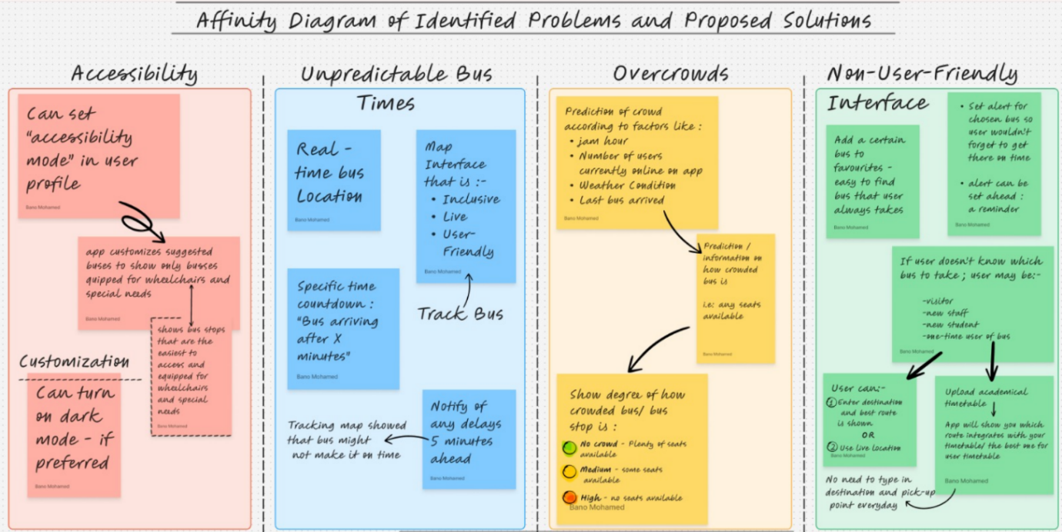

**5.3 Ideate Phase**

We held a brainstorming session on 13th January 2026, via Zoom. The meeting lasted 2 hours and the goal was to dump as many ideas as possible without looking at feasibility or impact. Then, we voted on the ideas based on the evaluation criteria. The ideas were further refined and expanded on these ideas with the help of generative AI such as Claude by Anthropic.

|  |
| --- |
| **Complete List of Ideas Generated:**   1. Live GPS tracking mobile app (like Grab for buses) 2. SMS notifications when bus is 5 minutes away 3. Digital LED display screens at major bus stops showing real-time ETAs 4. Mobile app with interactive route maps 5. QR codes at bus stops linking to live bus location webpage 6. Physical information kiosk at main campus locations 7. Integration with existing navigation apps (Google Maps, Waze) 8. Push notifications based on user's class timetable 9. Crowd-sourced location updates from bus passengers 10. AI-powered arrival predictions using historical data 11. Emergency alert system for bus breakdowns or delays 12. Multi-language support (Malay, English, Mandarin, Tamil) 13. Accessibility features (audio announcements for visually impaired) 14. Campus-wide digital signage network 15. Matric card enabled smart bus passes for tracking 16. Social features showing how many friends on each bus 17. Utilizing the TV on the buses to show the route and upcoming bus stops   **Idea Evaluation Criteria:**   1. Feasibility 2. Impact 3. Development Time 4. User Adoption 5. Cost/Resources |

|  |  |
| --- | --- |
| **Team Voting Results:**  After evaluation, each member voted for their top 3 choices: | |
| Live GPS tracking app | **5 votes** |
| Interactive route maps | **4 votes** |
| Push notifications: | **4 votes** |
| QR codes at stops | **2 votes** |
| SMS notifications | **1 vote** |

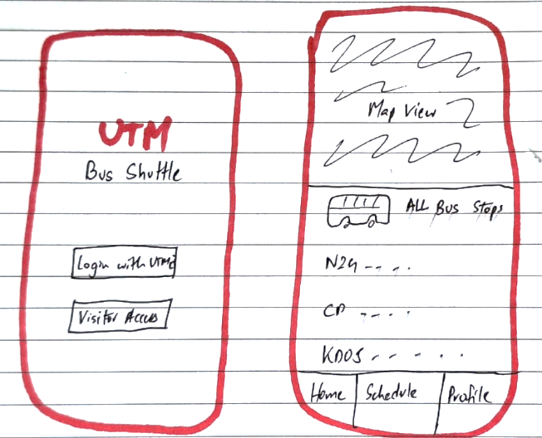We also drew sketches of how the app might look

**5.4 Prototype Phase**

We developed our prototype through three iterative cycles:

**V1: Basic Concept**

**Features:** Map interface with only a couple of bus routes added

**Components:**

* Interactive map of UTM campus using OpenStreet maps
* Bus Stop marker.

**V2: Information Layer**

**Changes from V1:**

* Added estimated arrival times at each bus stop
* Included bus stop names on map
* Added route line showing bus path
* Current time display

**Feedback:** Better but users confused about which direction bus is traveling

**V3: Enhanced Clarity**

**Changes from V2:**

* Directional arrows on route showing bus movement direction
* Color-coded bus lines (Blue Route, Red Route)
* "You are here" marker
* Next stop indicator
* Improved arrival time visibility

**Key Prototype Features:**

1. Authentication Flow: Login with UTM ID or guest access
2. Home Dashboard: Interactive map with live bus locations
3. Stop Details: Real-time arrivals, crowd levels, favorites
4. Schedule View: Daily/weekly timetables with personal integration
5. Notifications Center: Personalized alerts and updates
6. Profile & Settings: Dark mode, accessibility preferences, feedback

[Figma App Prototype Link](https://bulk-ozone-51058123.figma.site)

|  |  |  |
| --- | --- | --- |
| Main Screen | Login Page | Home page showing routes |
|  | | |  |  |
| Bus schedule and timetable | Important Notifications | User Profile Page |

**5.5 Test Phase**

During this phase we tested to check if our system satisfied the user-centric criteria and sought feedback from the UTM community. We wanted to know if the system was meeting the transparency and user support we had intended when proposing the solution.

1. Testing Objectives

Accuracy - Ensuring the live GPS tracking feature and arrival time estimations are accurate and matching the real-life movements of the buses.

Accessibility and Usability - Checking if the “Accessibility Mode” had successfully and correctly directed users to wheelchair-equipped facilities without any friction in use. Usability was an objective as well, for testing and receiving feedback on whether the interface was smooth to interact with, and the system was easy to figure out.

Anxiety Reduction -Testing if the push notifications effectively uplifted the burden of guesswork and made the experience of taking the bus worry-free.

1. User Feedback & Iteration

To help us achieve our User Testing Milestones, we engaged in a feedback and iteration loop:

Iterative Design **-** Changes were made to the "Prototype Fidelity" after every prototype session in Figma. This was to achieve a more intuitive interface.

Data Transparency **-** Users asked for more straightforward indicators of the degree of crowd. This led us to enhance the display of our “crowd prediction analysis” and make the feature more elaborate.

Ethical Verification **-** We reached out to users and confirmed their consent for the "anonymized statistics" collection to prevent any inconvenience and abide to our objective of ethical transparency.

**6. Reflections**

**6.1 Khalid**

The Design Thinking project has been extremely relevant to my plans of promoting ethical technology in the future. The fact that I have had direct interaction with the students as well as the visitors in the university has opened my eyes to the reality that technology should always have human considerations at its core and should not always rely on assumptions. The experiences I have had have made me understand the importance of adopting technology in a way that is respectful of human rights.

**6.2 Abdulrahman Mohammed**

This project helped me understand how important it is to design solutions based on real user needs instead of assumptions. By collecting survey responses and analyzing feedback, I realized how everyday problems, such as waiting for buses without information, can affect students and visitors on campus. Working with my group improved my communication and teamwork skills, especially when coordinating tasks and sharing ideas. Overall, this project gave me more confidence in using the Design Thinking process and showed me how technology can be used to improve real-life experiences on campus.

**6.3 Mohammed Rahbab Chowdhury**

My dream is to eventually lead product development teams that create innovative solutions for real-world problems. This project showed me that good leadership in tech isn't just about technical expertise - it's about facilitating collaboration, managing different perspectives, and keeping the team focused on user needs. What struck me most was during testing when users asked for features we hadn't even considered, like push notifications instead of manual checking. This taught me that assumptions are dangerous and user feedback is invaluable. To improve my industry potential, I need to build a portfolio of user-centered projects, practice presenting and defending design decisions, and learn to balance user needs with technical constraints and business goals. I also want to develop stronger skills in data analysis to better interpret user research findings.

**6.4 Nasma Mutasim**

It brought me to reflect deeply on what kind of technologist I want to become in the future. Working with real users made me aware of how innovation could and should start where humans are concerned. Through Design Thinking innovation, I was able to learn how technology could effectively function as both an enabler and an inhibitor, based on how this technology is leveraged. This project made me want to not only become an ethical technologist but also to take into consideration being user-centric, translucent, and impactful.

**6.5 Basma Mutasim**

I dream of promoting human-based, user-centric technologies that first and foremost stress ethical transparency. This design thinking project encouraged me to work harder for my dream and to stay on it. Seeing how students and campus visitors struggle with a system that is not user-focused, and speaking to many of them made me realize that user-centric design and technology is essential – it is not an option but a fundamental part of innovation. I plan to bridge the gap between technology and ethics so as to come up with digital innovations that serve users and protect their rights.

**7. Task for each member**

|  |  |
| --- | --- |
| **Team Member Name** | **Allocated Task** |
| *Abdulrahman Mohammed* | * Google Forms and Survey * Video (Ch#3-Detailed Problem and Solution) * Report (Ch#3-Detailed Problem and Solution) |
| *Mohammed Rahbab Chowdhury* | * Report (Layout, Formatting + Ch#2-Detail Steps & Description) * Video (Editing, Ch#2-Detail Steps & Description) * Google Forms * Prototype Design |
| *Basma Mutasim* | * Report (Ch#3-Detailed Problem and Solution) * Testing Phase – 5.5 * Video (Ch#4-Design Thinking Assessment) |
| *Nasma Mutasim* | * Report (Ch#5-Design Thinking Evidence) * Video (Ch#5-Design Thinking Evidence) |
| *Khalid* | * Interview * Prototype Design * Ideate Phase |

**8. References**

1. How to Write an Academic Report (<https://www.theclassroom.com/write-academic-report-5453496.html>)

2. The Interaction Design Foundation. (2016). *What is Design Thinking?* [online] Available at: <https://www.interaction-design.org/literature/topics/design-thinking?srsltid=AfmBOorVzy6X6Yk0VWY08YltzqON2vQqcO_ddTO-hWFamWoMWGJndA_r>

3. Dam, R.F. and Teo Yu Siang (2016). *What Is Empathy and Why Is It So Important in Design Thinking?* [online] The Interaction Design Foundation. Available at: <https://www.interaction-design.org/literature/article/design-thinking-getting-started-with-empathy?srsltid=AfmBOoot5aYUirOluMGefays1zT_vUZ_DtcHo8wRPi2Q1_lIFxNGxO6q>

‌4. Plattner, H. (2010). *An Introduction to Design Thinking Process Guide*. [online] Stanford University. Available at: <https://web.stanford.edu/~mshanks/MichaelShanks/files/509554.pdf>.

‌5. *Low Fidelity vs. High Fidelity Prototypes: Make the Decision at the Right Time*. [online] Available at: <https://miro.com/prototyping/low-fidelity-vs-high-fidelity-prototypes/>.